National University of Computer & Emerging Sciences

Object Oriented Programming Lab

Semester Project Report

Chess Game in C++

Submitted By
- Maira Ijaz (25F-3018)
- Umama Amir (25F-3061)
- Hina Irfan (25F-3003)

Introduction
The purpose of this project is to develop a Chess Game in C++ using Object-Oriented Programming concepts and the SFML graphics library. Chess is a strategic board game that requires proper implementation of game rules, move validation, player interaction, and game state management.
This project was designed to demonstrate the practical use of OOP concepts such as encapsulation, inheritance, polymorphism, abstraction, and composition. The application provides an interactive graphical interface where players can play chess with valid game mechanics.
The game supports both Player vs Player and Player vs AI modes with different difficulty levels. The project also includes advanced features such as move highlighting, drag-and-drop movement, pawn promotion, undo functionality, timers, move history, check/checkmate detection, and graphical menus.

Objectives
The main objectives of this project are:
- To implement a complete Chess Game using C++.
- To apply Object-Oriented Programming concepts in a real-world application.
- To create a graphical chess interface using SFML.
- To implement valid movement rules for all chess pieces.
- To detect check, checkmate, and stalemate conditions.
- To develop AI opponents with multiple difficulty levels.
- To improve problem-solving and programming skills.

Technologies Used
- Programming Language: C++
- Graphics Library: SFML (Simple and Fast Multimedia Library)
- Concepts Used: OOP, Dynamic Memory Allocation, GUI Design, Game Logic
- Development Environment: Visual Studio

Project Features

1. Complete Chess Board
- Standard 8×8 chessboard.
- Proper placement of all chess pieces.
- Graphical interface using SFML textures and sprites.

2. Chess Piece Classes
Separate classes were created for:
- Pawn
- Rook
- Knight
- Bishop
- Queen
- King
All classes inherit from a common base class named Piece.

3. Valid Move System
- Each chess piece follows its original movement rules.
- Illegal moves are prevented.
- Friendly pieces cannot capture each other.
- The king cannot move into check.

4. Turn-Based Gameplay
- White player moves first.
- Turns alternate automatically between players.

5. Check and Checkmate Detection
- The game detects when a king is under attack.
- Checkmate and stalemate conditions are implemented.
- Game over screen is displayed when the match ends.

6. Player vs AI Modes
The game supports:
- Player vs Player
- Player vs AI (Easy)
- Player vs AI (Medium)
- Player vs AI (Hard)
AI moves are generated using the Minimax algorithm with Alpha-Beta pruning.

7. Additional Features
- Undo move functionality
- Move history panel
- Drag-and-drop piece movement
- Move highlighting and hints
- Pawn promotion
- Timers for both players
- Responsive game window
- Interactive menus and instructions screen

Implementation of OOP Concepts

1. Encapsulation
Encapsulation was implemented by keeping class data members private or protected and providing public member functions to access them.
Example:
- The Piece class stores attributes such as:
  - piece color
  - movement status
  - texture
- These members are accessed using getter and setter functions.
class Piece {
protected:
Color color;
bool hasMoved;
sf::Texture* texture;
};
This protects the internal state of objects and improves maintainability.

2. Inheritance
Inheritance was implemented by creating derived classes for all chess pieces from the base class Piece.
Derived classes include:
- Pawn
- Rook
- Knight
- Bishop
- Queen
- King
class Pawn : public Piece
class Rook : public Piece
class Knight : public Piece
This reduced code duplication and allowed all pieces to share common properties.

3. Polymorphism
Polymorphism was implemented using virtual functions.
The Piece class contains pure virtual functions:
virtual bool isValidMove(...) const = 0;
virtual char getSymbol() const = 0;
Each derived class overrides these functions according to its own movement rules.
Examples:
- Pawn moves forward.
- Bishop moves diagonally.
- Knight moves in L-shape.
This allows dynamic behavior during runtime.

4. Composition
Composition was implemented through the Board class.
The Board class contains a two-dimensional array of Piece pointers:
Piece* board[8][8];
The board manages:
- piece placement
- move validation
- check detection
- move history
- undo operations
This demonstrates a strong “has-a” relationship.

5. Abstraction
Complex game logic was hidden behind simple interfaces.
For example:
- makeMove() handles complete move execution.
- isInCheck() detects threats to the king.
- hasLegalMove() checks game continuation.
The user interacts with the game without needing to understand internal implementation details.

AI Implementation
The AI system was implemented using the Minimax algorithm with Alpha-Beta pruning.
The AI:
- evaluates board positions,
- searches possible future moves,
- selects the best move according to piece values.
Different difficulty levels were implemented by changing the search depth:
- Easy → Depth 1
- Medium → Depth 2
- Hard → Depth 3
This feature improved the gameplay experience and added complexity to the project.

Working of the Program
- The program starts with the main menu.
- The player selects a game mode.
- The chessboard is initialized with all pieces.
- Players select and move pieces using the mouse.
- Valid moves are highlighted.
- The game continuously checks:
  - valid moves
  - check conditions
  - checkmate conditions
  - stalemate
- The game ends when:
  - a player is checkmated,
  - time runs out,
  - or a player forfeits.

Screenshots

Main Menu

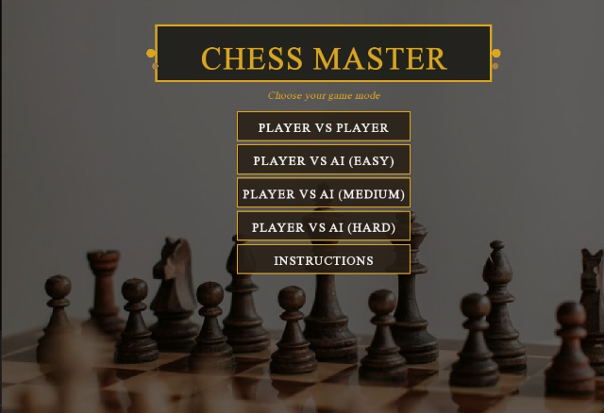

Chess Board Interface

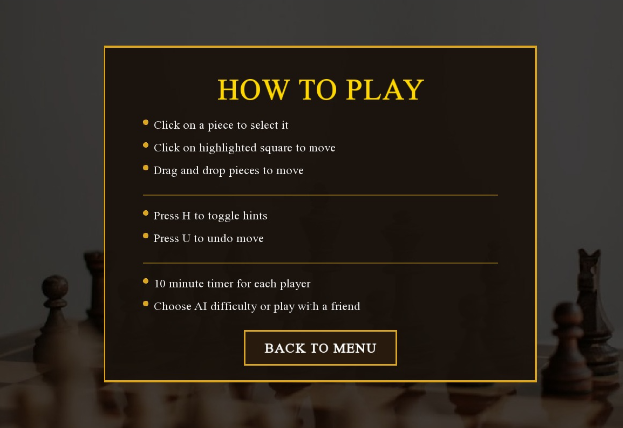

Valid Move Highlighting

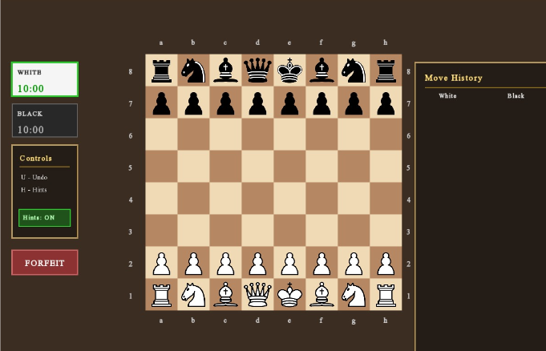

Move History and Timers

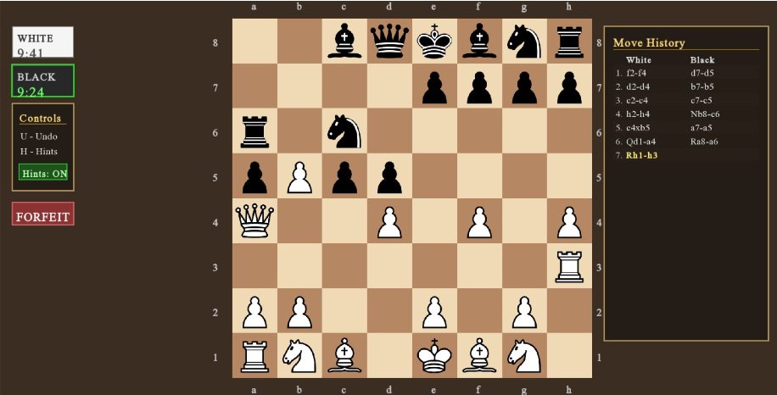

Challenges Faced
During the development of this project, several challenges were faced:
- Implementing correct movement rules for every chess piece.
- Detecting check and checkmate accurately.
- Managing dynamic memory properly.
- Designing AI using the Minimax algorithm.
- Creating a responsive graphical user interface.
- Synchronizing drag-and-drop movement with game logic.
These challenges helped improve understanding of game development and Object-Oriented Programming.

Conclusion
This Chess Game project successfully demonstrates the practical implementation of Object-Oriented Programming concepts using C++. The project includes both game logic and graphical interface design using SFML.
The use of inheritance, polymorphism, encapsulation, abstraction, and composition made the code modular, reusable, and easier to manage. Additional features such as AI modes, move history, timers, hints, and pawn promotion enhanced the overall functionality of the project.
This project improved our understanding of software design, problem solving, and real-world application development using OOP concepts.

GitHub Repository

https://github.com/f253061-debug/SFML-1.git

